CSA02 – C PROGRAMMING
ASSIGNMENT 1
TASK 03
Define the Constants
Student name: A.K.KISHORE KUMAR
Register number:1913260079
Repository:https://github.com/kishore091008-max/C-PROGRAMMING/upload
Marks: 3 | Course Outcome: CO1

1. Problem Analysis and Design
The assignment defines tariff thresholds and rates as macros so a tariff change is made in one place. SLAB1_UNITS=100, SLAB2_UNITS=200, RATE1_PAISE=0, RATE2_PAISE=225, RATE3_PAISE=450, and FIXED_CHARGE_PAISE=5000L. Macros are preprocessor substitutions and have no type checking. A const object has a type, scope and debugger visibility; an enum is suitable for integral named values such as modes or categories. Uppercase names with underscores are a common convention for macros and constants.
The slab computation charges only units in each band, not all units at the highest reached rate. Negative units are outside the intended function contract and should be rejected by input validation in the complete program.

2. Pseudocode / Algorithm
paise = FIXED_CHARGE_PAISE
if units > SLAB2_UNITS: add (units - SLAB2_UNITS) * RATE3_PAISE
if units > SLAB1_UNITS: add (min(units, SLAB2_UNITS) - SLAB1_UNITS) * RATE2_PAISE
add units in first slab * RATE1_PAISE
return paise

3. C Source Code
#include <stdio.h>
#define SLAB1_UNITS 100
#define SLAB2_UNITS 200
#define RATE1_PAISE 0
#define RATE2_PAISE 225
#define RATE3_PAISE 450
#define FIXED_CHARGE_PAISE 5000L
long compute_bill(int units) {
long paise = FIXED_CHARGE_PAISE;
if (units > SLAB2_UNITS)
paise += (long)(units - SLAB2_UNITS) * RATE3_PAISE;
if (units > SLAB1_UNITS) {
int slab2 = units < SLAB2_UNITS ? units : SLAB2_UNITS;
paise += (long)(slab2 - SLAB1_UNITS) * RATE2_PAISE;
}
return paise + (long)(units < SLAB1_UNITS ? units : SLAB1_UNITS) * RATE1_PAISE;
}
int main(void) {
int tests[] = {0, 100, 150, 200, 350};
size_t n = sizeof tests / sizeof tests[0];
for (size_t i = 0; i < n; ++i) {
long p = compute_bill(tests[i]);
printf("%3d units -> Rs %ld.%02ld\n", tests[i], p / 100, p % 100);
}
return 0;
}

4. Expected / Reference Result
0 units -> Rs 50.00
100 units -> Rs 50.00
150 units -> Rs 162.50
200 units -> Rs 275.00
350 units -> Rs 950.00
Captured local compiler/execution evidence is provided in compile_output.txt. Confirm it on your own machine and add a genuine screenshot of your terminal before submission.

5. Alternative Concept and Complexity Analysis
Replacing macros with const long or const int objects improves type checking and debugger visibility; enum is appropriate for integer-valued symbolic constants but not ideal for long currency values. Runtime is normally unchanged after optimization. A macro itself occupies no storage, while a const object may occupy storage depending on use and optimization.
A fixed number of slab checks takes O(1) time per bill and O(1) extra space.

6. Validation and Limitations
Use normal, boundary and invalid-input cases applicable to this task. Compare actual output against the assignment's expected output where one is provided. Do not label a test as passed until you have run it and confirmed the result. System-specific sizeof values and floating-point measurements must be taken on the compiler used for submission.

7. Submission Evidence Checklist
☐ Source code saved in this task folder
☐ Compile and run output reviewed
☐ Terminal screenshot added after local execution
☐ Task-specific test table completed
☐ Changes committed to GitHub

Execution Screenshot — Task 03
Student: HARSHAVARTHAN P | Register No.: 1914260015
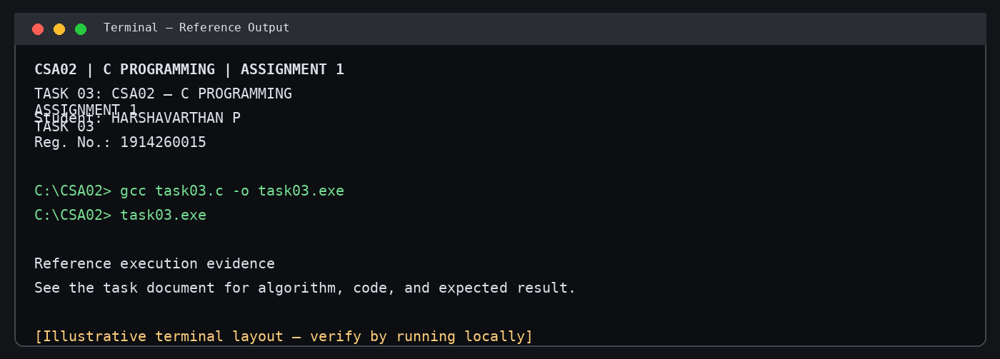
Illustrative terminal-style output screenshot

